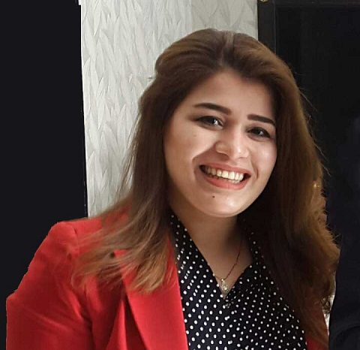

**Name**: **Halima Loqman Mohammed**

**Date of Birth:** 16 July 1992

**E-mail:** halimaloqman@gmail.com

**Mobile:**  00964 751 042 33 76

**Marital Status:** Single

**Nationality:**  Iraqi

|  |
| --- |
| **SKILLS** |

* Sound ability to learn, interpret and apply policies, procedures, and resolutions.
* In-depth ability to prioritize multiple assignments.
* Immense ability to maintain a good working relationship with all co-workers, vendors, clients and the public and to use good judgment in recognizing scope of authority.
* Strong interpersonal, communication, and organizational skills.
* Proven experience in greeting and responding to the general public in a fast-paced, service-oriented environment.
* Demonstrated high-level of abilities of various computer    software programs and fluency in using standard office software packages (MS Office: Access, Excel, Word, PowerPoint, and Outlook).

|  |
| --- |
| **EXPERIENCE** |

# From 22-03-2016 till now

# Working as Payroll assistant/HR coordinator for MAF Carrefour Kurdistan Iraq

* Remarkable ability to retain a large variety of information and interpret it to various publics.
* Profound ability to respond to varied requests and perform several duties at the same time.
* Excellent ability to deal effectively with a variety of personalities and situations requiring tact, judgment, and poise.
* Pays employees by calculating pay; distributing checks; maintaining records.
* Administers student loan, medical insurance, and disability programs by advising employees of eligibility; providing application information; helping with form completion; verifying submission; notifying employees of approvals.
* Documents human resources actions by completing forms, reports, logs, and records.
* Updates job knowledge by participating in educational opportunities; reading professional publications.
* Accomplishes human resources department and organization mission by completing related results as needed.
* Maintains human resources records by recording new hires, transfers, terminations, changes in job classifications, merit increases; tracking vacation, sick, and personal time.
* Verbal Communication
* Orients new employees by providing orientation information packets; reviewing company policies; gathering withholding and other payroll information; explaining and obtaining signatures for benefit programs.
* Gather Payroll Data like Bank Accounts , transfer , promotions , warning litters and addition – Deduction list )
* Respond to Employees Question about benefits (e.g. number of vacation days they are eligible, salaries and payments).
* Coordinate HR events (job Fair, Career days, popular event and meetings).
* Update our internal databases with employees’ full information like contact Details, Visa, Residency, Passport and health insurance card).
* Check payroll information for accuracy and ensure all relevant paperwork is in order
* Coordinate with HR about changes in payroll (e.g. terminations, new hires)
* Prepare electronic payments and distribution for all suppliers that HR dealing with, terminations, resigning Employees and New joiner while payroll checks or Bank accounts.
* Handle benefit expenses, like insurance fees or paid leave.
* Implement functional HRMS and internal databases across all departments and locations.
* Prepare budgets by department.

|  |
| --- |
| **EDUCATION** |

**From 01-11-2015 to 01-03-2016**

Training as receptionist at **Erbil International Hotel**

* Reservations
* Welcoming guests
* Check-in/out
* Worked with Sky horizon system

**From October 2011 to June 2015:**

Graduated from Iraqi University field **Art of English (Iraq-Baghdad)**

**2010-2011:** High school certificate in literary.

|  |
| --- |
| **COMPUTER SKILLS** |

**Windows 7**

**Excel 2010**

**Power Point**

**Microsoft Word**

|  |
| --- |
| **LANGUAGES** |

**1- Arabic: (Native Language)**

**2- Kurdish: (Good)**

**3-English: (Fluent)**